**Week 5:  Ethical Hacking Fundamentals**

**Objective:**  Perform safe, simulated penetration tests.

**Task#01: Set up a Kali Linux VM and explore its tools: Nmap, Wireshark, Metasploit.**

**Solution:**

**Set up a Kali Linux VM:**



**Nmap:**

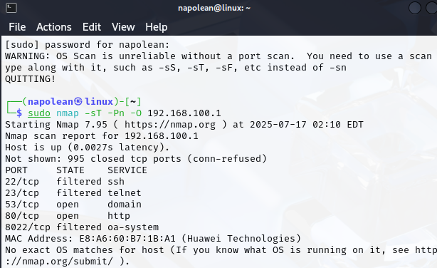

**WireShark:**

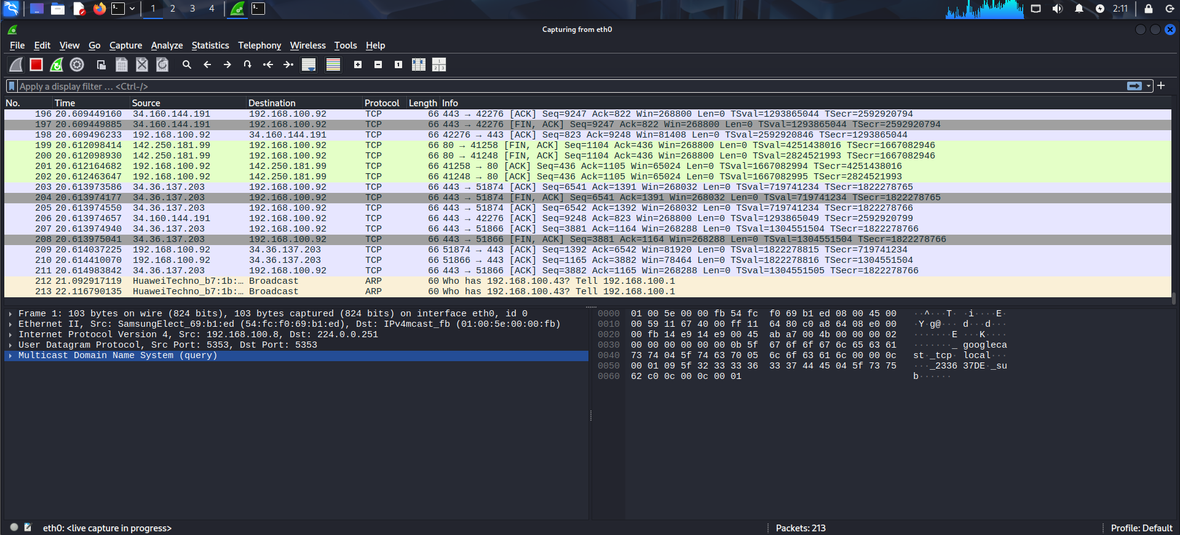

**Metasploit:**

